**9 SCIENCE BIOLOGY SENSORY RECEPTORS INVESTIGATION 2016**



Name:_______________________ Teacher: ____________________

Form:_______________________ Due date:____________________

**Plagiarism**

You must write in your **own words**, not copy sentences word for word from another student or another source.

Plagiarising = instant zero on assignment.

**Assessment policy**

Extensions are not given on the day an assessment is due.

Give me a sick note/legitimate reason from parent BEFORE due date = new negotiated due date.

One day late = -20% taken off mark.

Two days late = -40% taken off mark.

Three days late = mark of zero given and students are required to attend a detention and are still required to submit the assignment.

**If you are not at school the day this assignment is due, please email it to me by the 4pm deadline.**

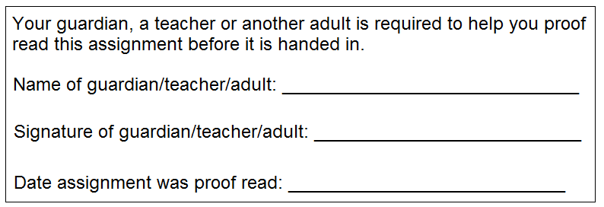**_________________________@aranmore.wa.edu.au**

**Aim:** Your skin contains many touch receptors. Your task is to determine how far apart the touch receptors are in different parts of your body. You will determine the distance using two toothpicks. If the toothpicks touch the skin very close together they will feel like one toothpick as only one touch receptor has been stimulated. When you can feel two toothpicks then you know two touch receptors have been stimulated.

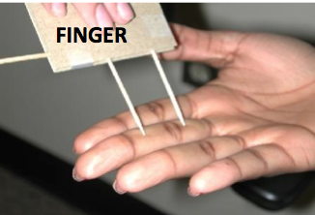

**Recommended resources:**

Video: Redesign my Brain Season 2 Episode 2 (looks at touch receptors) 35:12-45:15min

Video: Sense of Touch: 1:46min: https://www.youtube.com/watch?v=mQoS62jEvNA

Website: Skin Structure and Texture: http://www.abpischools.org.uk/page/modules/skin/.cfm?coSiteNavigation_allTopic=1

Website: Sense of Touch: http://www.hometrainingtools.com/a/skin-touch

**Notes about sensory receptors**

_________________________________________________________________________________________________

_________________________________________________________________________________________________

_________________________________________________________________________________________________

_________________________________________________________________________________________________

_________________________________________________________________________________________________

_________________________________________________________________________________________________

_________________________________________________________________________________________________

_________________________________________________________________________________________________

_________________________________________________________________________________________________

_________________________________________________________________________________________________

_________________________________________________________________________________________________

_________________________________________________________________________________________________

_________________________________________________________________________________________________

_________________________________________________________________________________________________

_________________________________________________________________________________________________

_________________________________________________________________________________________________

_________________________________________________________________________________________________

_________________________________________________________________________________________________

_________________________________________________________________________________________________

**Title** (descriptive, not ‘biology investigation’) (1 mark)

_________________________________________________________________________________________________

**Aim** (one sentence that describes what you are trying to find out in the investigation) (1 mark)

_________________________________________________________________________________________________

_________________________________________________________________________________________________

**Introduction** (include background information that people need to know to understand your investigation, e.g. what are touch receptors? Minimum of three sentences.) (3 marks)

_________________________________________________________________________________________________

_________________________________________________________________________________________________

_________________________________________________________________________________________________

_________________________________________________________________________________________________

_________________________________________________________________________________________________

_________________________________________________________________________________________________

_________________________________________________________________________________________________

_________________________________________________________________________________________________

_________________________________________________________________________________________________

_________________________________________________________________________________________________

_________________________________________________________________________________________________

_________________________________________________________________________________________________

_________________________________________________________________________________________________

_________________________________________________________________________________________________

_________________________________________________________________________________________________

**Hypothesis** (one sentence prediction including dependent and independent variables which does not use personal language like ‘I’, ‘we’)  (2 marks)

_________________________________________________________________________________________________

_________________________________________________________________________________________________

_________________________________________________________________________________________________

_________________________________________________________________________________________________

**Materials** (detailed, how many of each item that was used) (1 mark)

___________________________________ ______________________________________

___________________________________ ______________________________________

**Independent variable:**  (1 mark)

_________________________________________________________________________________________________

**Dependent variable:** (1 mark)

_________________________________________________________________________________________________

**Two controlled variables** (variables kept constant throughout the experiment to keep it fair) (2 marks)

_________________________________________________________________________________________________

_________________________________________________________________________________________________

**Method** (starting from step one, list the steps that were taken) (3 marks)

_________________________________________________________________________________________________

_________________________________________________________________________________________________

_________________________________________________________________________________________________

_________________________________________________________________________________________________

_________________________________________________________________________________________________

_________________________________________________________________________________________________

_________________________________________________________________________________________________

_________________________________________________________________________________________________

_________________________________________________________________________________________________

_________________________________________________________________________________________________

_________________________________________________________________________________________________

_________________________________________________________________________________________________

_________________________________________________________________________________________________

_________________________________________________________________________________________________

_________________________________________________________________________________________________

_________________________________________________________________________________________________

_________________________________________________________________________________________________

_________________________________________________________________________________________________

_________________________________________________________________________________________________

_________________________________________________________________________________________________

_________________________________________________________________________________________________

_________________________________________________________________________________________________

_________________________________________________________________________________________________

_________________________________________________________________________________________________

**Results**

**Table** (show the results taken from experiment, trials and averages, in pencil and using a ruler) (3 marks)

**Graph** (show your group’s **average** results in a graph using a sharp lead pencil and ruler)(6 marks)



**Discussion** (describe one mistake or error that occurred, explain how it affected the results and how it could be avoided next time)

Remember that a mistake can be avoided with care and an error is a small change to measurement that cannot be avoided (parallax error, reading error, instrument error, human reflex etc.) (3 marks)

_________________________________________________________________________________________________

_________________________________________________________________________________________________

_________________________________________________________________________________________________

_________________________________________________________________________________________________

_________________________________________________________________________________________________

_________________________________________________________________________________________________

_________________________________________________________________________________________________

_________________________________________________________________________________________________

_________________________________________________________________________________________________

_________________________________________________________________________________________________

_________________________________________________________________________________________________

_________________________________________________________________________________________________

_________________________________________________________________________________________________

_________________________________________________________________________________________________

_________________________________________________________________________________________________

_________________________________________________________________________________________________

_________________________________________________________________________________________________

_________________________________________________________________________________________________

**Conclusion** (state the result of the experiment, state whether the hypothesis was supported or not supported, scientific reasons to explain results. Minimum of four sentences)(5 marks)

_________________________________________________________________________________________________

_________________________________________________________________________________________________

_________________________________________________________________________________________________

_________________________________________________________________________________________________

_________________________________________________________________________________________________

_________________________________________________________________________________________________

_________________________________________________________________________________________________

_________________________________________________________________________________________________

_________________________________________________________________________________________________

_________________________________________________________________________________________________

_________________________________________________________________________________________________

_________________________________________________________________________________________________

_________________________________________________________________________________________________

_________________________________________________________________________________________________

_________________________________________________________________________________________________

_________________________________________________________________________________________________

_________________________________________________________________________________________________

_________________________________________________________________________________________________

_________________________________________________________________________________________________

_________________________________________________________________________________________________

_________________________________________________________________________________________________

_________________________________________________________________________________________________

_________________________________________________________________________________________________

_________________________________________________________________________________________________

_________________________________________________________________________________________________

_________________________________________________________________________________________________

_________________________________________________________________________________________________

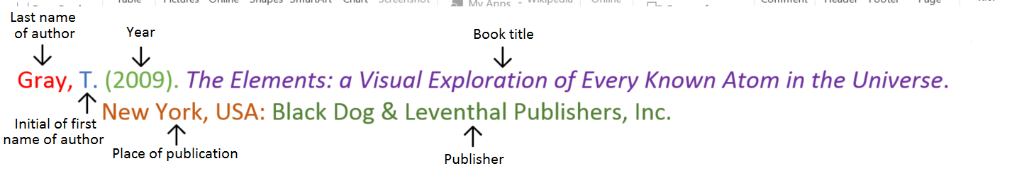**Book**

**Book with two authors**

Shermer, M., & Benjamin, A. (2006). *Secrets of Mental Math: The Mathemagician’s Guide to Lightning Calculation and Amazing Mental Math Tricks*. New York, USA: Three Rivers Press.

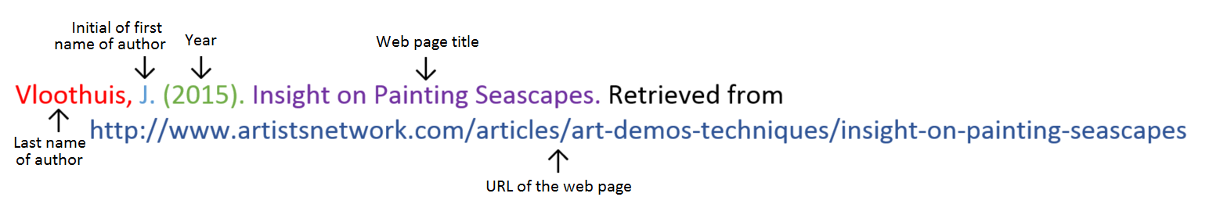

**Website**

**Website with no author** (put the title from the top of the website at the front)

Aranmore Catholic College. (2014). Retrieved from http://www.aranmore.wa.edu.au/

**Website with no date** (put n.d in brackets instead of a year)

The Zadkine Museum. (n.d). Retrieved from http://www.france.fr/en/museums/zadkine-museum.html



**Video file**

**Reference list**

Referenced using the APA style shown on the next page. (1 mark)

Minimum of two references. (1 mark)

_________________________________________________________________________________________________

_________________________________________________________________________________________________

_________________________________________________________________________________________________

_________________________________________________________________________________________________

_________________________________________________________________________________________________

_________________________________________________________________________________________________

_________________________________________________________________________________________________

_________________________________________________________________________________________________

_________________________________________________________________________________________________

Assignment is neatly written or typed. (1 mark)

Correct spelling and grammar. (1 mark) Mark as percentage: % /36

Teacher comment: on Seqta